***SchoolTrack***

***Table of Contents***

1. ***Introduction***
2. ***Application Design Diagram***
3. ***How to run***

***Introduction***

SchoolTrack uses Java and the Springboot Framework for the backend and PostgreSQL as it relational database for storing data. The front end uses HTML and CSS. The Thymeleaf dependency was used to send data from the backend to the frontend through the data model. The application JAR is packaged with the TOMCAT web server and once the application is started, it can be run from <http://localhost:8080/>.

***Application Design Diagram***

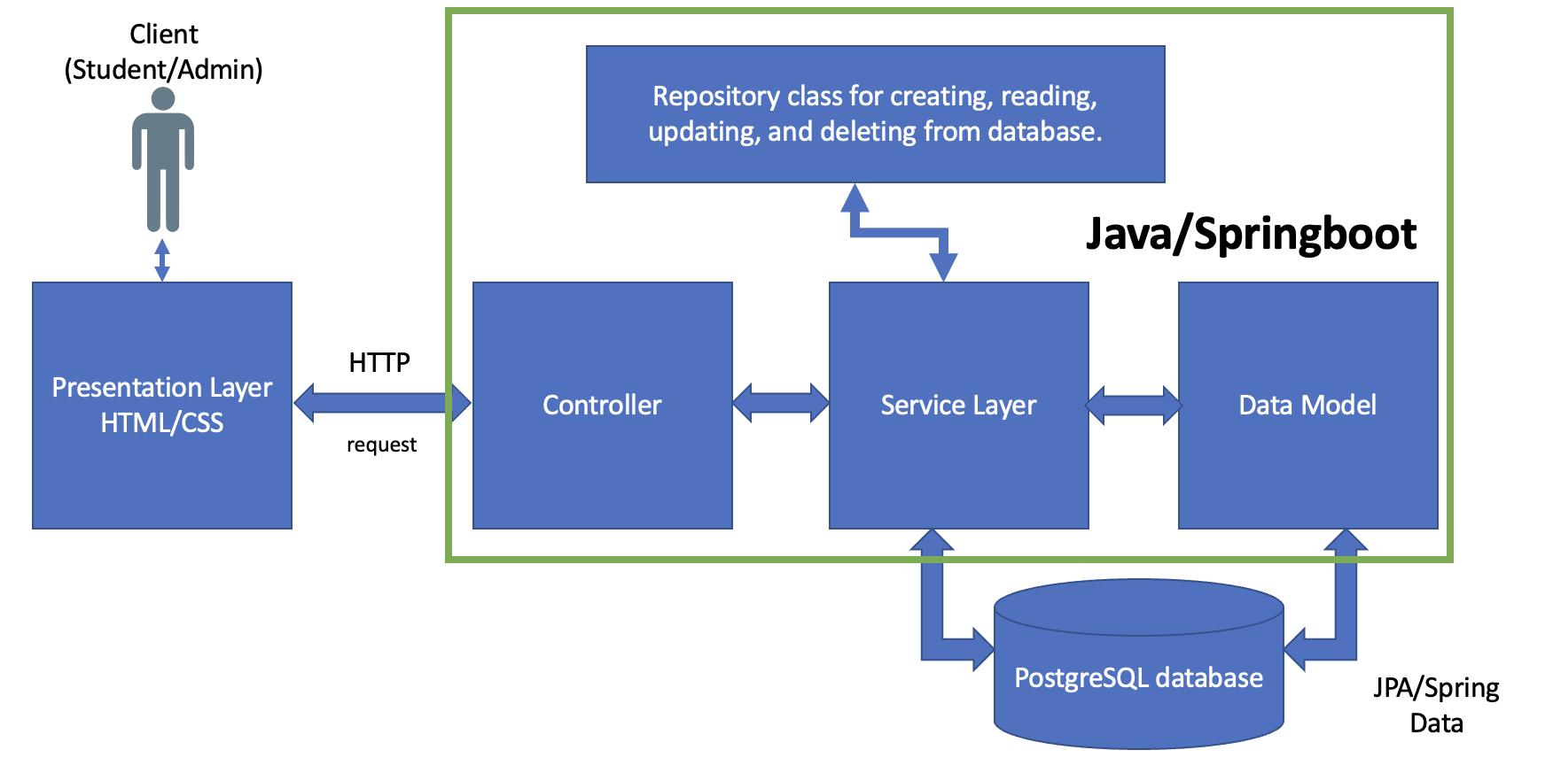

***How to run***

1. Install PostgreSQL for your device. <https://www.postgresql.org/download/>
2. Install the latest version of Java for your device. <https://www.oracle.com/in/java/technologies/downloads/>
3. Download the JAR File from my GitHub project target folder. Link: <https://github.com/shivanimk19/event-tracker/tree/main/eventtracker/target>
4. Run the program with this command.

java -jar eventtracker-0.0.1-SNAPSHOT.jar

1. Once the application has started, open a web browser and type in <http://localhost:8080/> to start the program
2. The admin can enter credentials and click login. (Username: [admin@commack.k12.ny.us](mailto:admin@commack.k12.ny.us), Password: 1234).